**Record of Ex. No: 11 –Building Drawing**

**Date of experiment:** 06.07.2021 **Date of submission: 06.07**.2021

**Name:** Kunal Keshan S **Department:** ECE – A **Roll No:** RA2011004010051

**Aim:**

To learn and draw the plan, elevation and sectional elevation of a building.

**Software used:** AutoCAD.

**Procedure:**

|  |  |
| --- | --- |
| Commands Used | Purpose of Command |
| UNITS | To set the units of the drawings. |
| LIMITS | To set the limits of the drawing area. |
| ZOOM | To adjust the view of the drawing area. |
| LINE | Used to draw a line. |
| POINT | Used to place a point on the drawing area. |
| TEXT | Used to add text in the drawing area. |
| TEXTEDIT | Used to edit any existing text. |
| DIMLINEAR | Used to add linear dimensions. |
| DIMALIGNED | Used to add aligned dimensions (i.e parallel to a line or point that is not perpendicular) |
| DIMANGLE | Used to add dimensions between any two lines or arcs. |
| DDPTYPE | Used to set the type of point and its size. |
| HATCH | Used to give required and custom hatching to selected regions. |
| RECT | Used to draw rectangle. |
| SCALE | Used to scale objects to a required ratio. |
| MOVE | Used to move objects with respect to a base point. |
| OFFSET | Used to replicate objects at a certain set distance. |
| MIRROR | Used to mirror objects with respect to a mirror line. |

**Steps:**

1. Adjust the right units and limits of the drawing area using UNITS AND LIMITS.
2. Using LINE and RECT tool, make the top view of the mentioned dimensions. Use the required tools, OFFSET, MIRROR and such to create the required specifications.
3. Now draw a reference line above the PLAN (also known as the top view).
4. Using the PLAN, now draw the front view (or ELEVATION) of the building.
5. After completing the ELEVATION, use it draw the Sectional View of the building.
6. Use HATCH tool to give the required hatching.
7. Use DIM tool to give dimensions to all the views.
8. Use TEXT tool to mark the door, windows and other specifications separately.

**Question 1:**

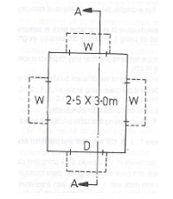

Answer:

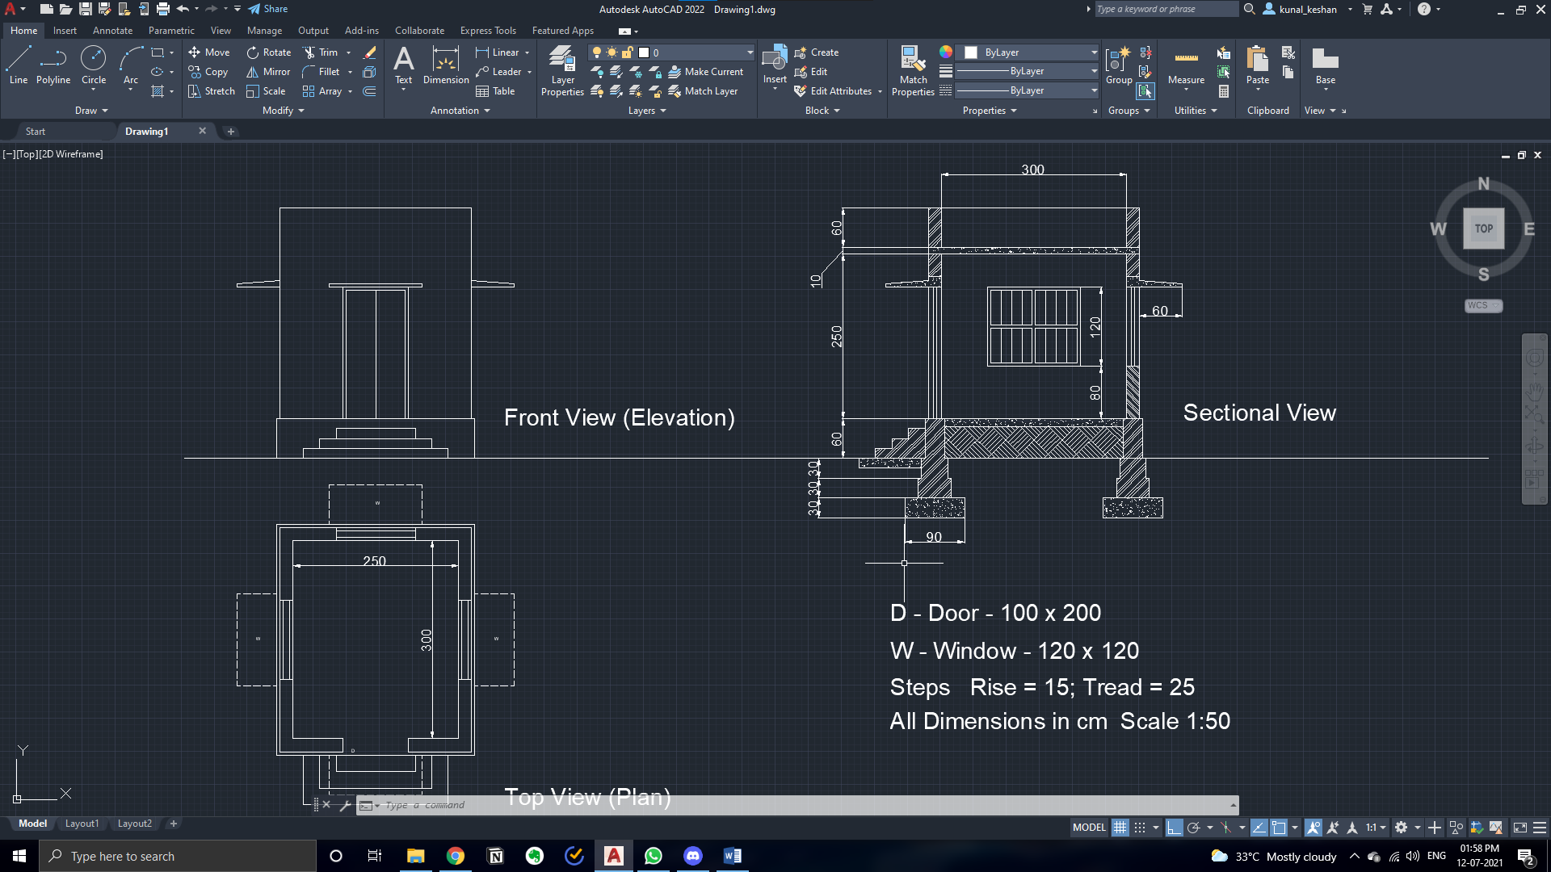

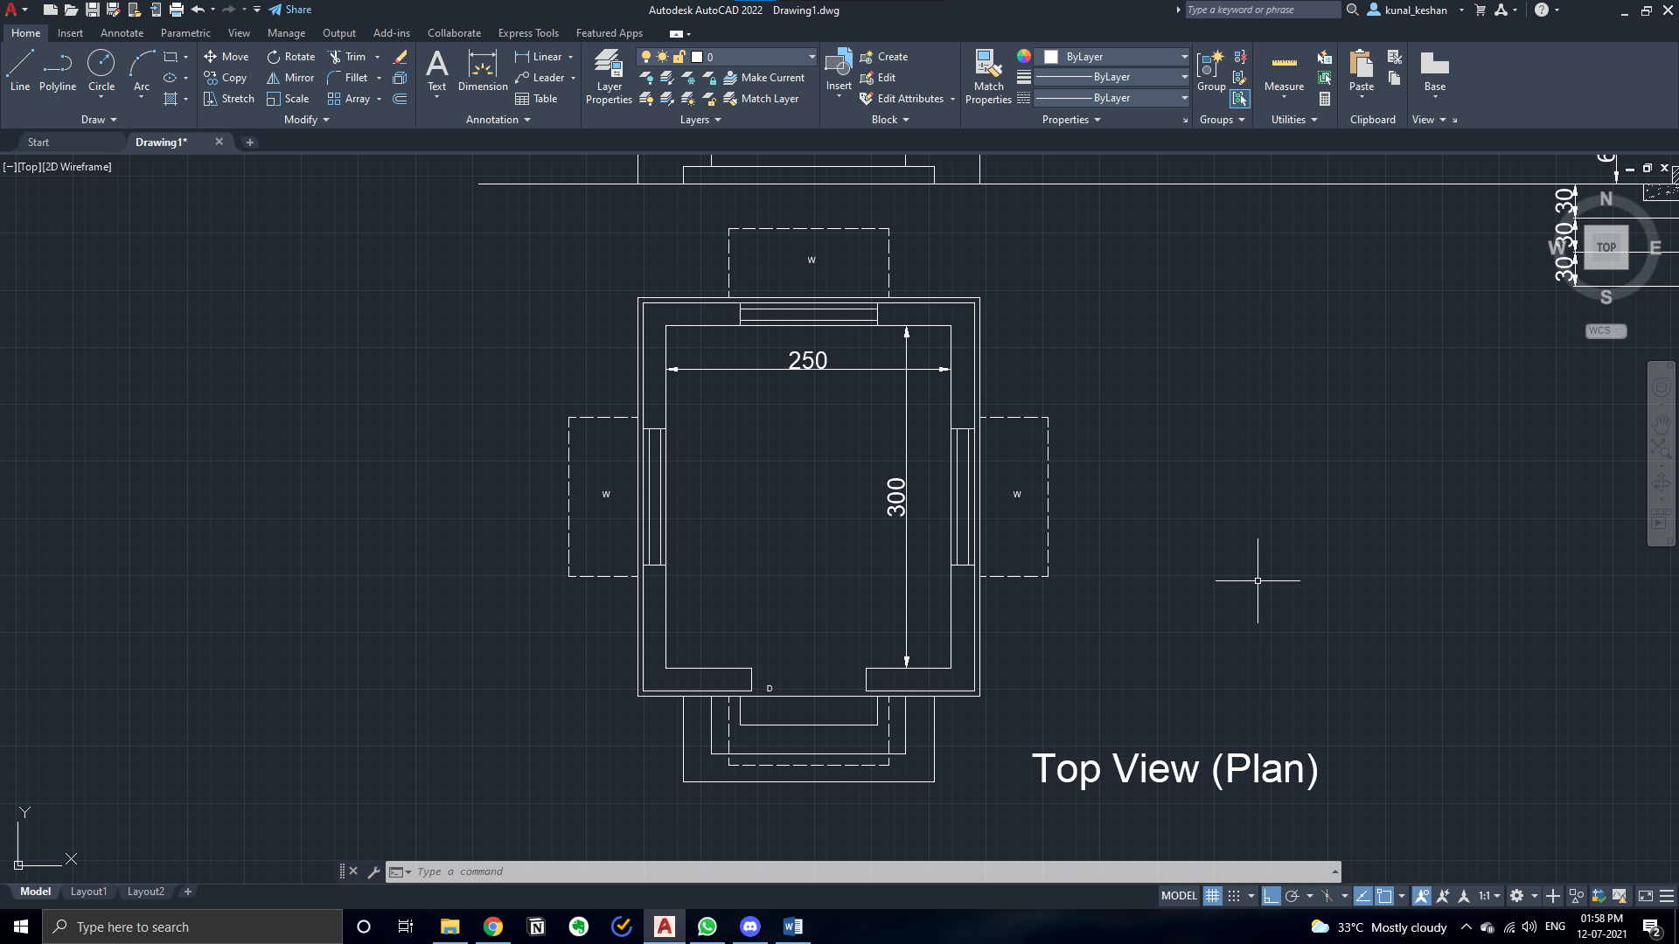

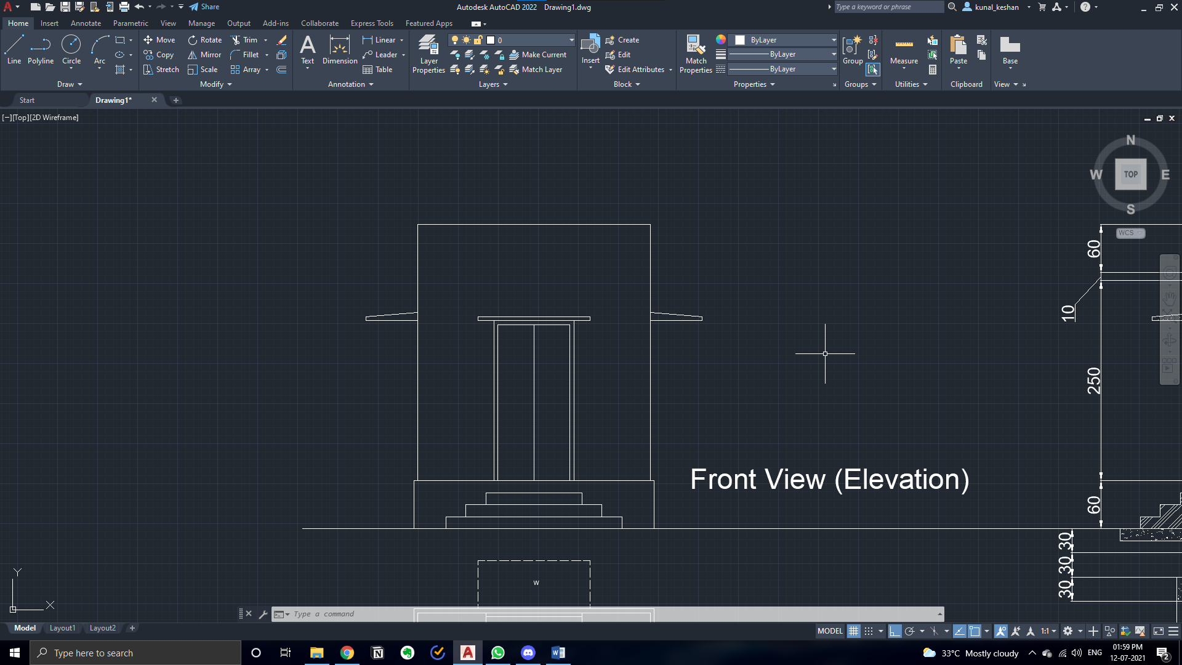

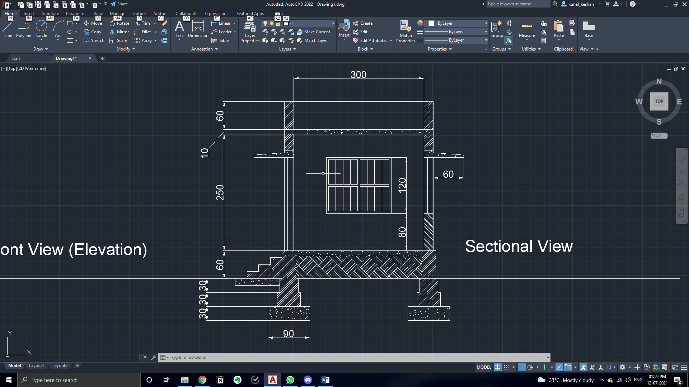

**Result:**

The given plan, elevation and sectional view of the building were drawn using AutoCAD.